**Load Testing ScreenShot**

1. Thread user 100 and Ramp-up Period 60 sec:

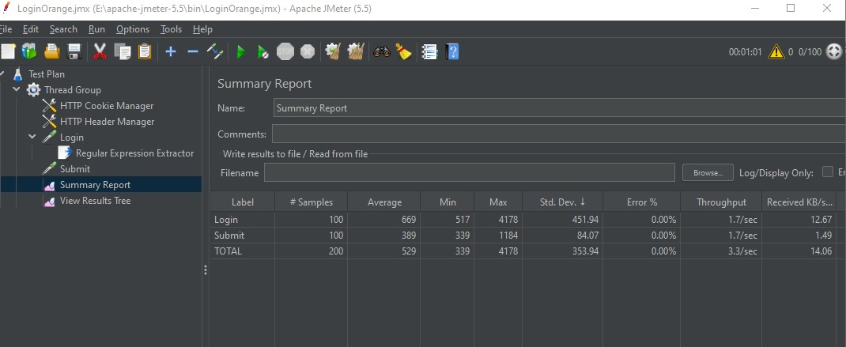

1. Thread user 150 and Ramp-up Period 90 sec:

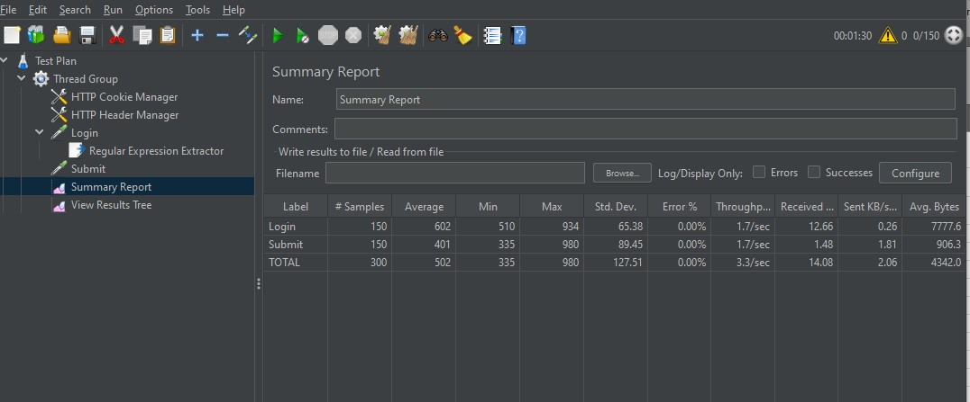

1. Thread user 500 and Ramp-up Period 300 sec:

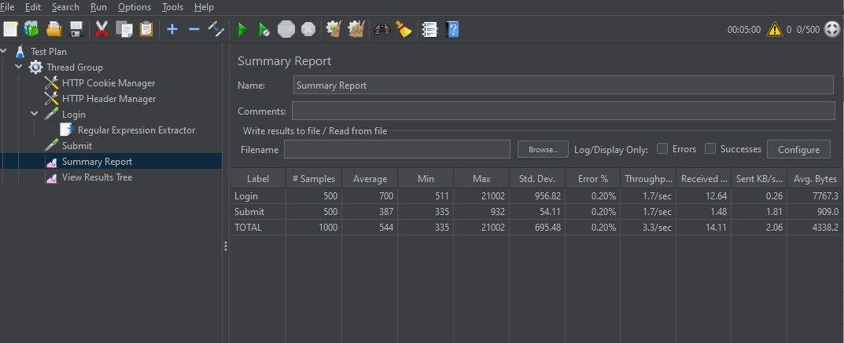

1. Thread user 500 and Ramp-up Period 350 sec:

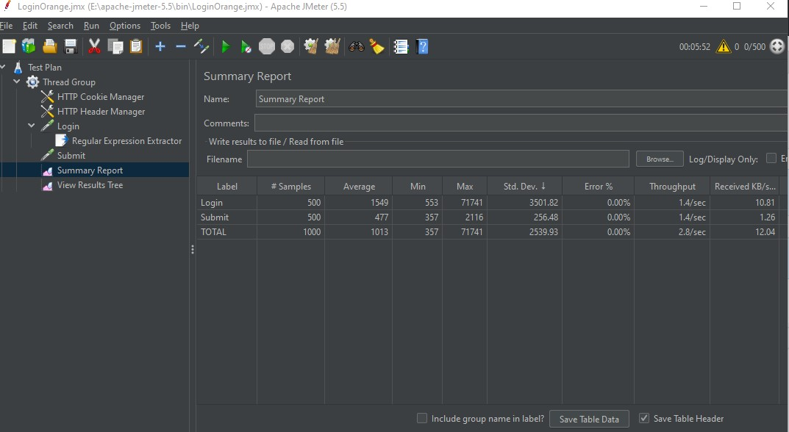

1. Thread user 1000 and Ramp-up Period 600 sec:

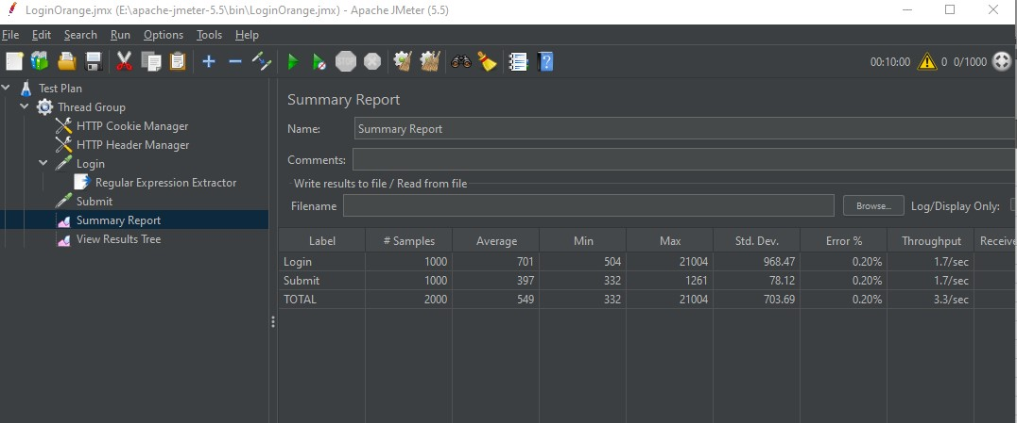

1. Thread user 1000 and Ramp-up Period 650 sec:

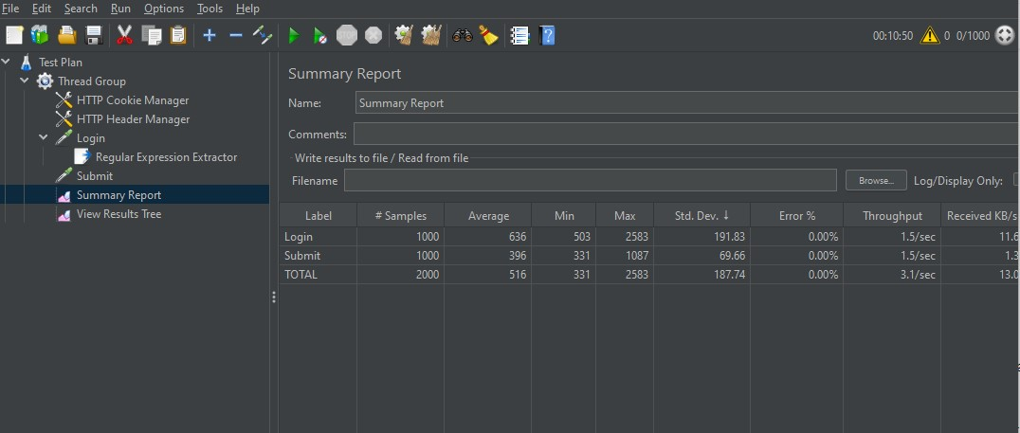

1. Thread user 1000 and Ramp-up Period 625 sec:

